**Supplementary material**

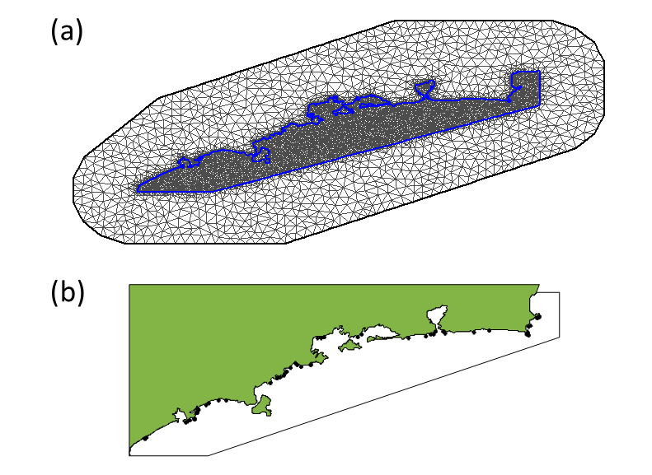

**Figure S1**. Mesh used in spatial models predicting average barnacle density per location. The mesh (*a*) is made out of triangles of varying side length, with the maximum length set to 5 km and 25 km for the inner and outer region. The sampling locations (*b*: black dots) are in the inner region; the outer region is created in order to facilitate computations at the border of the mesh. The mesh is made out of 8131 nodes, providing a matrix for the calculation of the spatially correlated random effects. For the barrier model, the same mesh is used but with constraints imposed at the limits of the inner mesh (demarcated by a blue line).

*Environmental drivers*

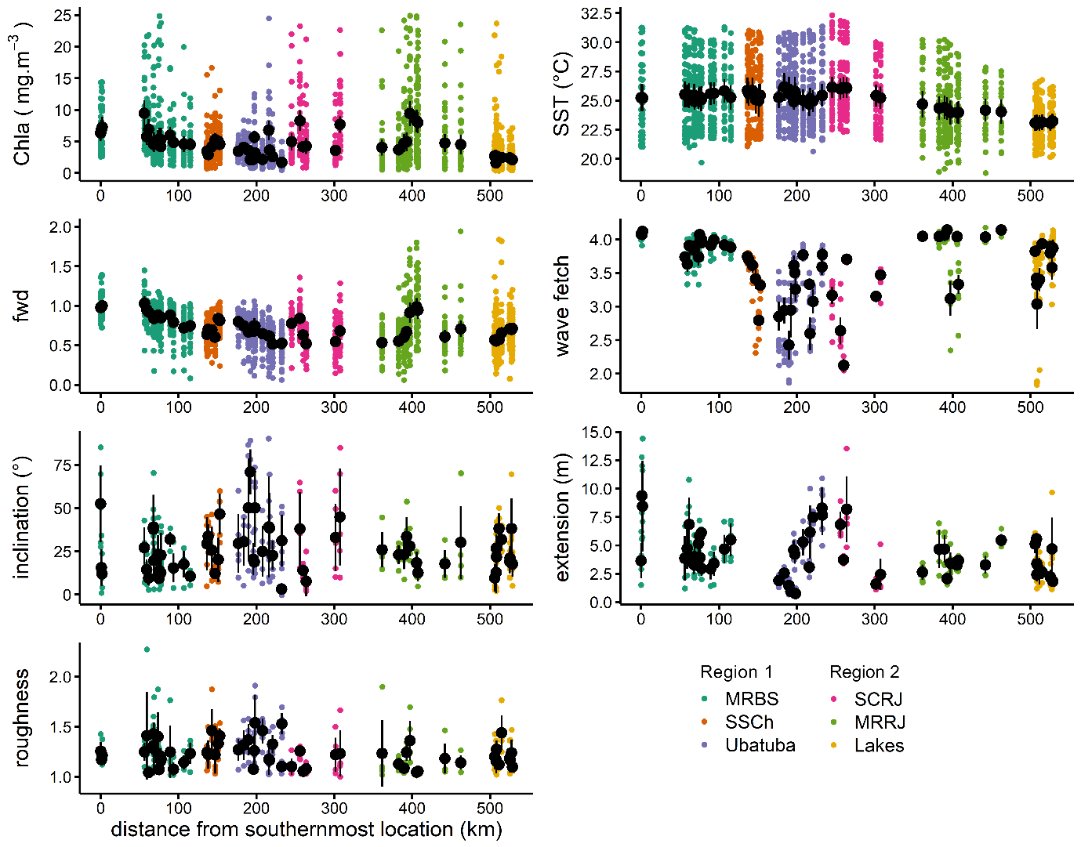

**Figure S1.** Environmental variables measured for studied locations along southeast coast of Brazil. Coloured circles are raw data while black circle and error bars represent mean ± 2SE. Distance from southernmost location was used as *x*-axis since SE coast of Brazil is very intricate and locations tens of kilometres apart may have same or close latitudes. Wave fetch is shown in log10 number of cells. *Abbreviations*: fwd = freshwater discharge index; MRBS = Metropolitan Region of Baixada Santista; SSCh = São Sebastião Channel; SCRJ = south coast of Rio de Janeiro; MRRJ = Metropolitan Region of Rio de Janeiro. (Source: Pardal-Souza *et al.* 2021)

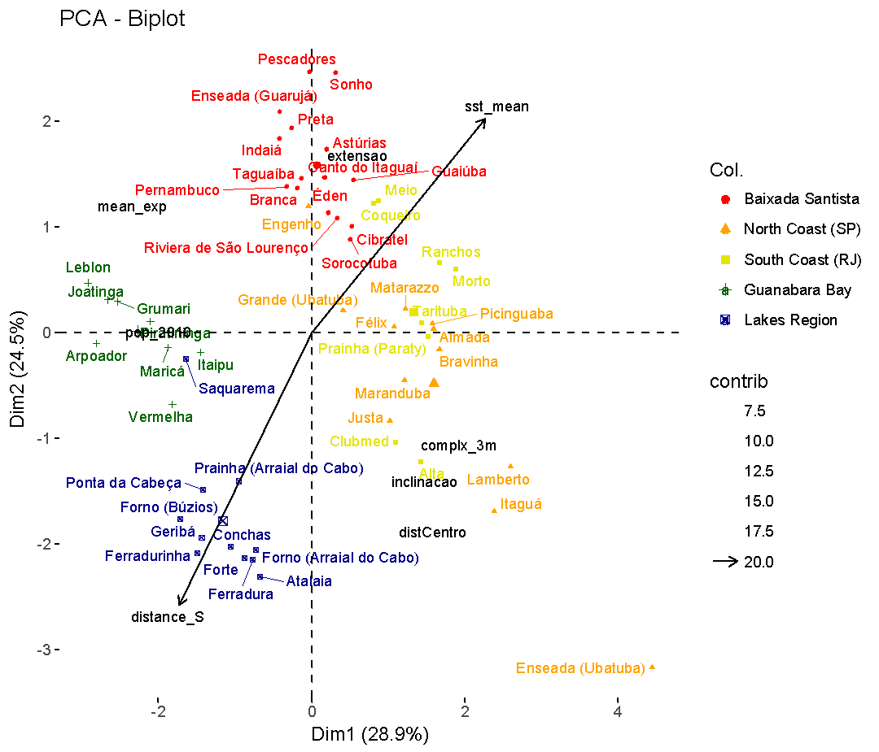

Figure S2.

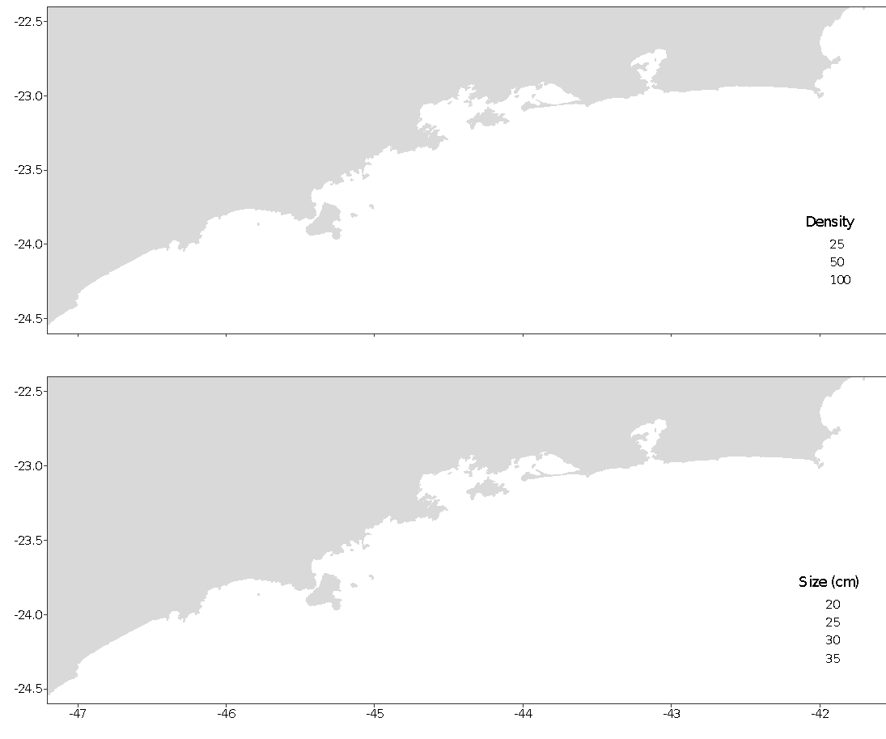

**Figure S2**. Size and density (ind. 625 cm-2) of *Stramonita haemastona* along 62 rocky shores at southwestern Atlantic coast (Brazil).

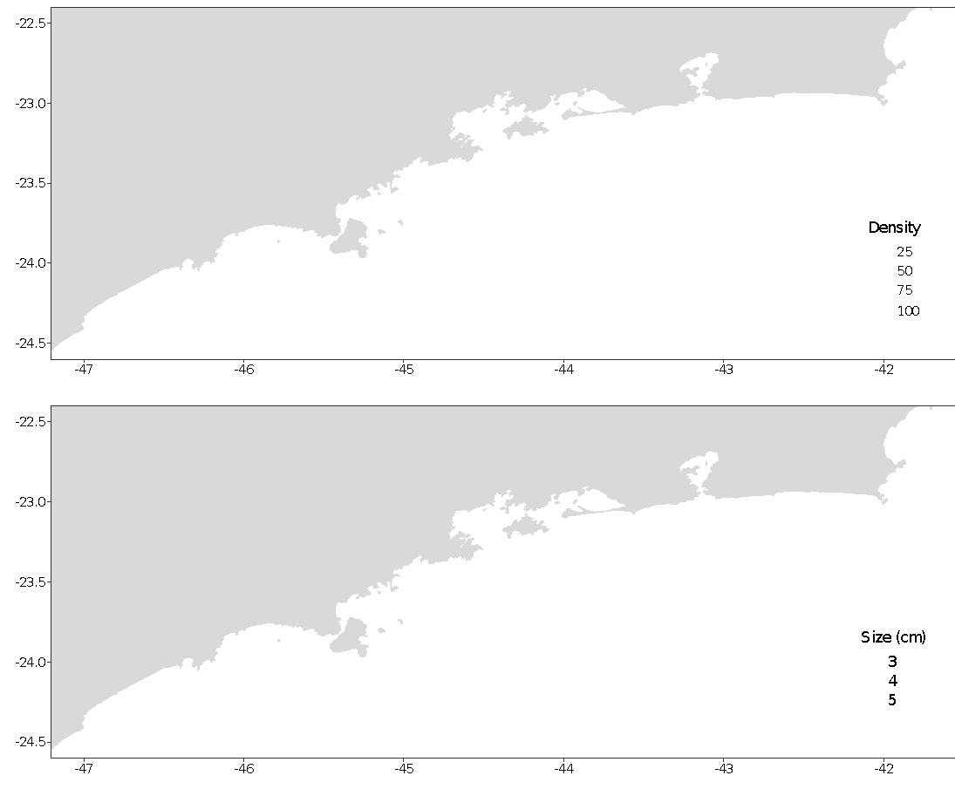

**Figure S3**. Size and density (ind. 100 cm-2) of *Tetraclita stalactifera* along 62 rocky shores at southwestern Atlantic coast (Brazil).

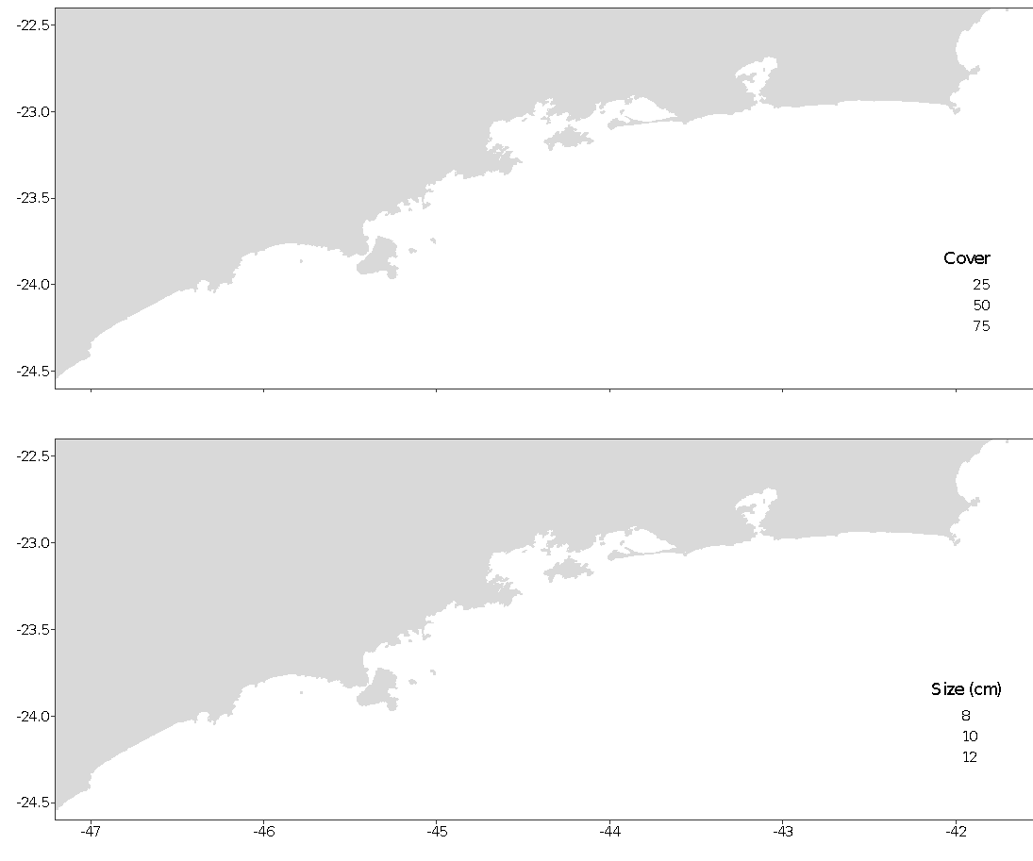

**Figure S4**. Relative cover (%) and size of *Mytilaster solisianus* along 62 rocky shores at southwestern Atlantic coast (Brazil).

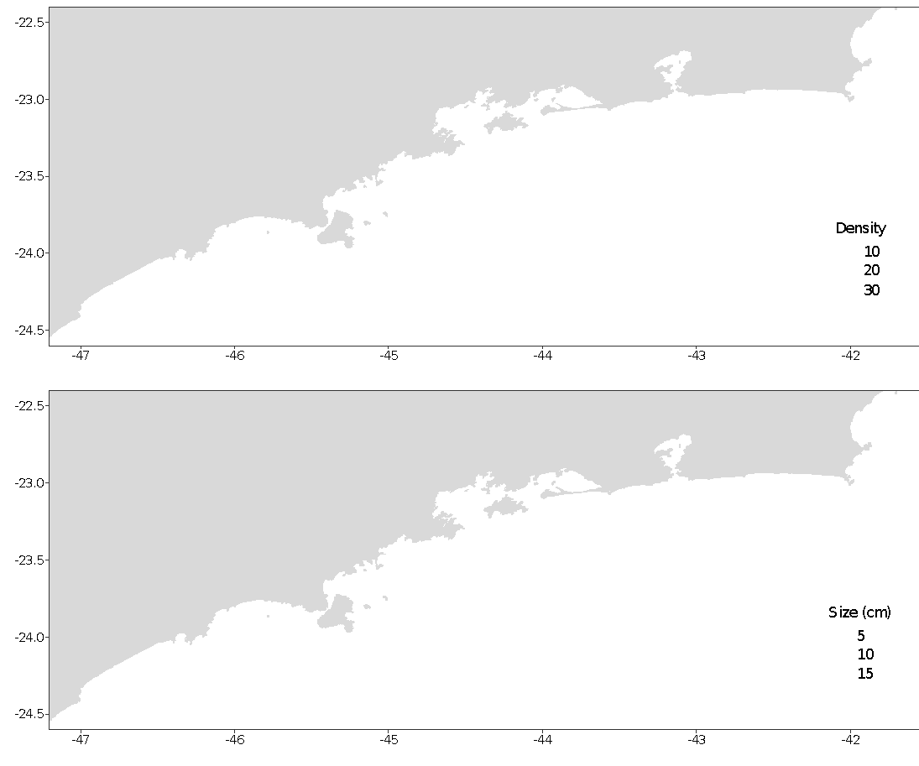

**Figure S5**. Size and density (ind. 100 cm-2) of *Lottia subrugosa* along 62 rocky shores at southwestern Atlantic coast (Brazil).

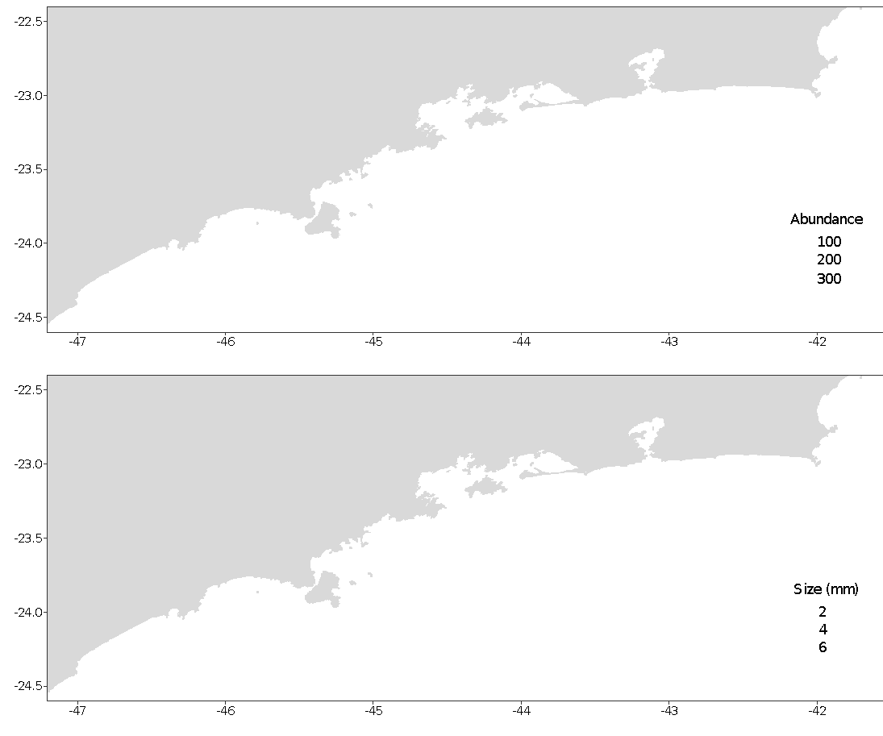 **Figure S**6 Size and abundance of *Echinolittorina lineolata* along 62 rocky shores at southwestern Atlantic coast (Brazil).

**Appendix A: Model selection and validation**

Before starting the analysis, all variables were explored for descriptive statistics (distribution type, central tendency, value range), simple correlations, collinearity and spatial dependency which are not shown here. Below are described the indicated statistics from model selection and validation.

*Biological indicators*

**Table A1.** Fully nested random models fitted (residual maximum likelihood method) for size and density of whelk *Stramonita haemastoma* in rocky shores along southeast coast of Brazil. Selection of the best model was based on lowest AICc value, next model higher complexity or ΔAIC > 3. Abbreviations: R = region, S = subregion and L = location. Size was log-transformed. Models for density including ‘location’ could not be tested because of lack of replication at this level.

| **Size (Gaussian distribution, identity link)** | | | |  | **Density (Negative binomial, log link)** | | | |
| --- | --- | --- | --- | --- | --- | --- | --- | --- |
| **model** | **logLik** | **AICc** | **dAICc** |  | **model** | **logLik** | **AICc** | **dAICc** |
| ~ L* | -13.2 | 56.8 | 0 |  | ~ R* | -73.6 | 198.0 | 0.0 |
| ~ S | -238.4 | 507.2 | 450.5 |  | ~ S | -73.6 | 198.0 | 0.0 |
| ~ R + S + L f | - | - | - |  | ~ R + S | -73.6 | 203.1 | 5.1 |
| ~ R + S f | - | - | - |  |  |  |  |  |
| ~ R + L f | - | - | - |  |  |  |  |  |
| ~ S + L f | - | - | - |  |  |  |  |  |
| ~ R f | - | - | - |  |  |  |  |  |

* best random structure. f - model did not converge. Fixed structure of models: size or density ~ shore extension + shore inclination + wave fetch + SST + roughness + [Chl-a] + NDVI + *Tetraclita stalactifera* density + *T. stalactifera* cover + *Mytilaster* *solisianus* cover + *M. solisianus* size

| (a) | (b) |
| --- | --- |

**Figure A1***.* Plots of residuals versus fitted values, mean wave fetch (km log) and histogram of residuals of best model for *Stramonita haemastoma* size (a) and density (b). A smooth spline is shown for scatterplots graphs.

**Table A2.** Fully nested random models fitted (residual maximum likelihood method) for size and density of barnacle *Tetraclita stalactifera* in rocky shores along southeast coast of Brazil. Selection of the best model was based on lowest AICc value, next model higher complexity or ΔAIC > 3. Abbreviations: R = region, S = subregion and L = location. Size was log-transformed.

| **Size (Gaussian distribution, identity link)** | | | |  | **Density (Negative binomial, log link)** | | | |
| --- | --- | --- | --- | --- | --- | --- | --- | --- |
|  | **logLik** | **AICc** | **dAICc** |  | **logLik** | **logLik** | **AICc** | **dAICc** |
| ~ L* | -37.2 | 101.0 | 0.0 |  | ~ L* | -2975.2 | 5976.9 | 0.0 |
| ~ S + L | -37.2 | 103.1 | 1.1 |  | ~ S + L | -2975.2 | 5978.9 | 2.0 |
| ~ R + L | -37.2 | 103.1 | 1.1 |  | ~ R + L | -2975.2 | 5979.0 | 2.1 |
| ~ R | -91.5 | 209.6 | 4.2 |  | ~ R + S + L | -2975.2 | 5981.0 | 4.1. |
| ~ S | -91.5 | 211.6 | 108.6 |  | ~ S | -3100.1 | 6226.8 | 249.9 |
| ~ R + S | -92.6 | 211.8 | 110.6 |  | ~ R + S | -3100.1 | 6228.9 | 252.0 |
| ~ R + S + L f | - | - | - |  | ~ R | -3111.2 | 6248.9 | 272.0 |

* best random structure. f - model did not converge. Fixed structure of models: size or density ~ shore extension + shore inclination + wave fetch + SST + roughness + [Chl-a] + NDVI + *Stramonita haemastoma* size + *S. haemastoma* abundance

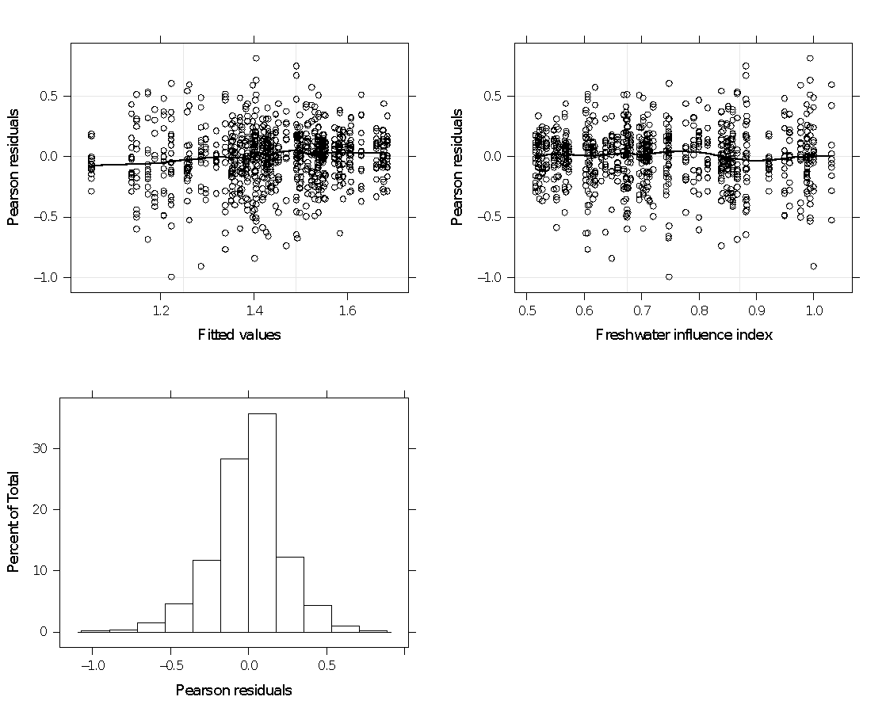

**Figure A2***.* Plots of residuals versus fitted values, freshwater influence index and histogram of residuals of best model for *Tetraclita stalactifera* size. A smooth spline is shown for scatterplots graphs.

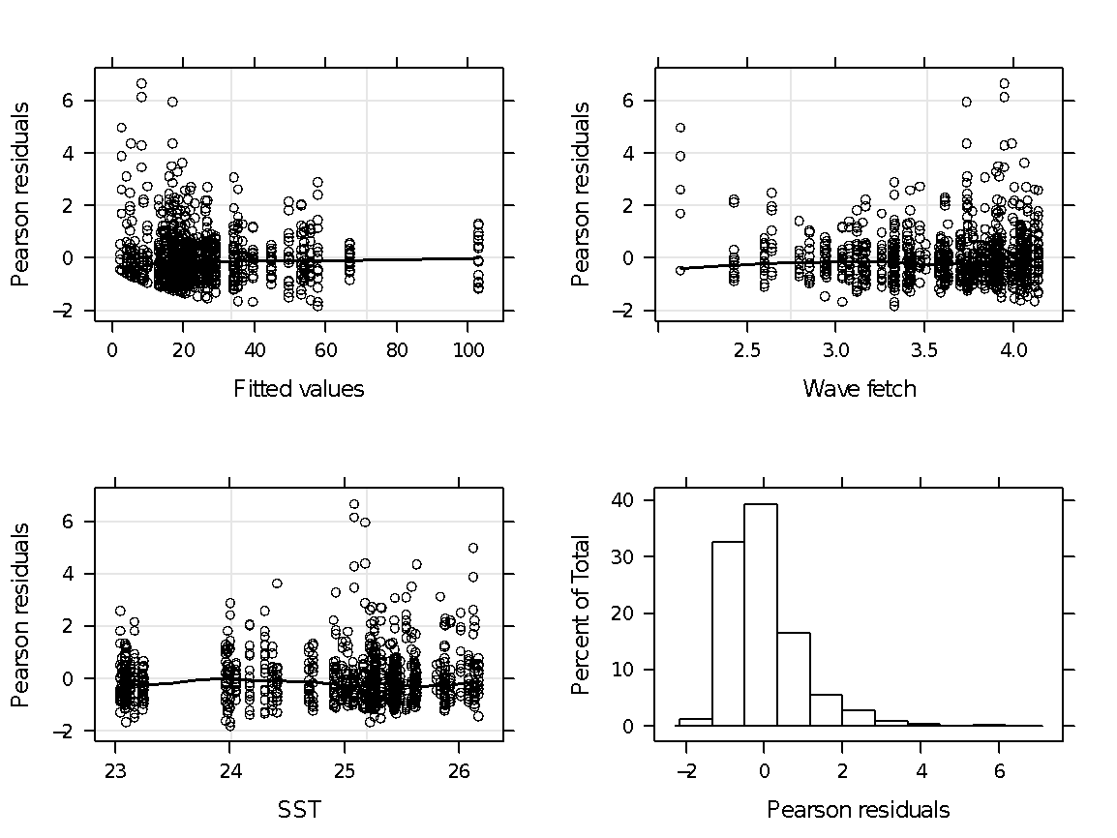

**Figure A3***.* Plots of residuals versus fitted values, mean wave fetch (log km), mean sea surface temperature (SST °C) and histogram of residuals of best model for *Tetraclita stalactifera* density. A smooth spline is shown for scatterplots graphs.

**Table A3.** Summary statistics for models of *Tetraclita stalactifera* densities fitted through general least square model with sea surface temperature and wave fetch.

| **Model** | **AIC** | **logLik** | **df** | **P-value** |
| --- | --- | --- | --- | --- |
| Non-spatial | 7220.4 | -3605.2 | 5 |  |
| AR1 | 7224.4 | -3605.2 | 7 | 1 |

| (a) |
| --- |
| (b) |

**Figure A4.** (a) Spline correlogram (95% bootstrap confidence intervals) for Pearson residuals from best model for *Tetraclita stalactifera* density along studied area. (b) Plot of Pearson residuals in space (UTM coordinates). Distance in kilometres. Coastline was removed for facilitating visualization.

*Mytillaster solisianus*

**Table A4.** Fully nested random models fitted (residual maximum likelihood method) for size and density of barnacle *Mytillaster solisianus* in rocky shores along southeast coast of Brazil. Selection of the best model was based on lowest AICc value, next model higher complexity or ΔAIC > 3. Abbreviations: R = region, S = subregion and L = location. Size was log-transformed.

| Size (Gaussian distribution, identity link) | | | | |  | Cover (Binomial, logit link) | | | | |
| --- | --- | --- | --- | --- | --- | --- | --- | --- | --- | --- |
|  | logLik | AICc | dAICc |  | |  | logitLik | AICc | dAICc |
| ~ L* | -14531.5 | 29089.0 | 0.0 |  | | ~ L* | 6.9 | 490.4 | 0.0 |
| ~ R + L | -14531.0 | 29090.1 | 1.1 |  | | ~ R + L | 6.9 | 492.4 | 2.0 |
| ~ S + L | -14531.3 | 29090.8 | 1.7 |  | | ~ S + L | 6.9 | 492.6 | 2.1 |
| ~ S | -14706.2 | 29438.5 | 3.1 |  | | ~ R | 0.7 | 502.7 | 12.2 |
| ~ R + S | -14705.7 | 29439.5 | 349.4 |  | | ~ S | 0.0 | 504.1 | 13.7 |
| ~ R | -14720.6 | 29467.3 | 350.5 |  | | ~ R + S | 0.7 | 504.8 | 14.4 |
| ~ R + S + Lf | - | - | - |  | | ~ R + S + Lf | - | - | - |

* best random structure; f - model did not converge. Fixed structure of models: size or density ~ shore extension + shore inclination + wave fetch + SST + roughness + [Chl-a] + NDVI + *Stramonita haemastoma* size + *S. haemastoma* abundance

| (a) | (b) |
| --- | --- |

**Figure A5***.* Plots of residuals versus fitted values, mean wave fetch (km log) and histogram of residuals of best model for *Mytilaster solisianus* size (a) and density (b). A smooth spline is shown for scatterplots graphs.

**Table A5.** Fully nested random models fitted (residual maximum likelihood method) for size and density of limpet *Lottia subrugosa* in rocky shores along southeast coast of Brazil. Selection of the best model was based on lowest AICc value, next model higher complexity or ΔAIC > 3. Abbreviations: R = region, S = subregion and L = location. Size was log-transformed.

| **Size (Gaussian distribution, identity link)** | | | |  | | **Density (Negative binomial, log link)** | | | | |
| --- | --- | --- | --- | --- | --- | --- | --- | --- | --- | --- |
|  | **logLik** | **AICc** | **dAICc** | |  | | **logLik** | **logLik** | **AICc** | **dAICc** |
| ~ S + L* | -341.8 | 708.2 | 0.0 | |  | | ~ L* | 1530.0 | 3080.3 | 0.0 |
| ~ R + S + L s | -341.8 | 710.3 | 2.1 | |  | | ~ S + L | 1530.0 | 3082.4 | 2.1 |
| ~ L | -345.6 | 713.5 | 5.4 | |  | | ~ R + L | 1530.0 | 3082.4 | 2.1 |
| ~ R + L | -345.6 | 715.6 | 7.4 | |  | | ~ R + S + L | 1530.0 | 3084.5 | 4.1 |
| ~ S | -414.6 | 851.5 | 143.4 | |  | | ~ S | 1578.5 | 3177.3 | 97.0 |
| ~ R + S s | -414.6 | 853.6 | 145.4 | |  | | ~ R + S | 1578.5 | 3179.4 | 99.0 |
| ~ R | -454.2 | 930.9 | 222.7 | |  | | ~ R | 1581.4 | 3183.2 | 102.8 |

* best random structure. s – models with singular fit. Fixed structure of models: size or density ~ shore extension + shore inclination + wave fetch + SST + roughness + [Chl-a] + NDVI

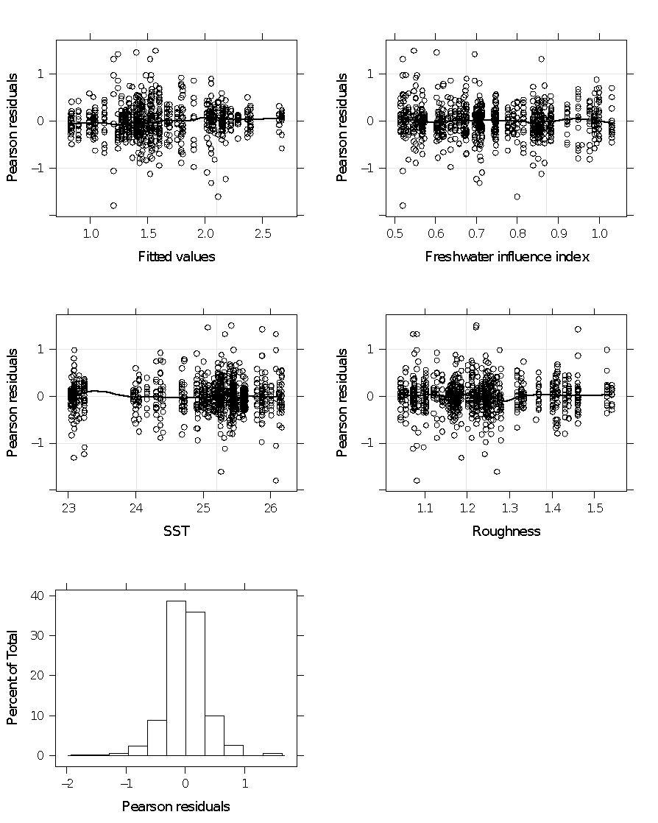

**Figure A6***.* Plots of residuals versus fitted values, freshwater influence index, mean sea surface temperature (SST °C), substrate roughness and histogram of residuals of best model for *Lottia subrugosa* size. A smooth spline is shown for scatterplots graphs.

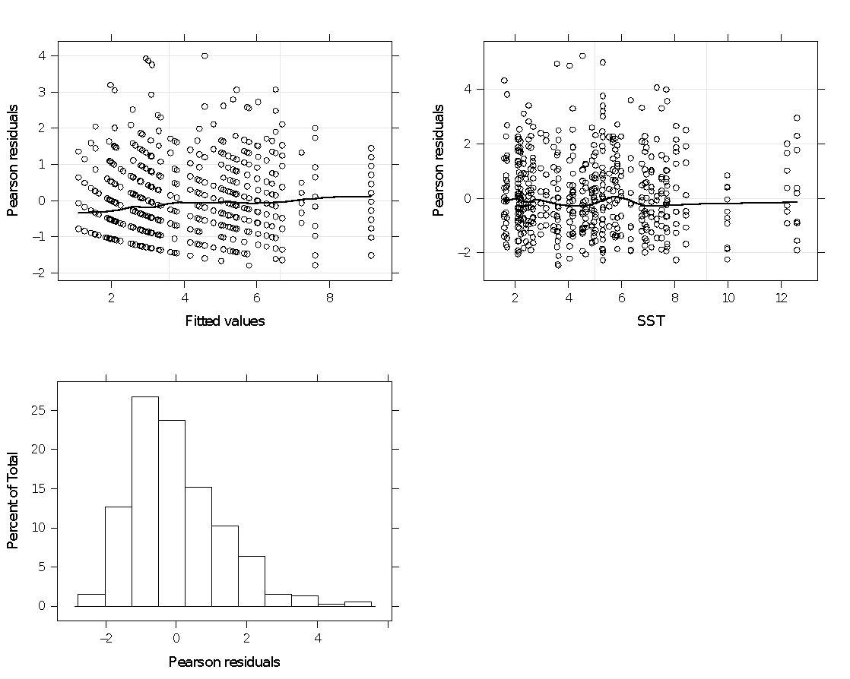

**Figure A7***.* Plots of residuals versus fitted values, mean sea surface temperature (SST °C) and histogram of residuals of best model for *Lottia subrugosa* density. A smooth spline is shown for scatterplots graphs.

*Echinolittorina lineolate* spatial model

**Table A6.** Fully nested random models fitted (residual maximum likelihood method) for size and density of barnacle *Echinolittorina lineolata* in rocky shores along southeast coast of Brazil. Selection of the best model was based on lowest AICc value, next model higher complexity or ΔAIC > 3. Abbreviations: R = region, S = subregion and L = location. Size was log-transformed. Models for density including ‘location’ could not be tested because of lack of replication at this level.

| **Size (Gaussian distribution, identity link)** | | | |  | **Density (negative binomial, log link)** | | | | |
| --- | --- | --- | --- | --- | --- | --- | --- | --- | --- |
|  | **logLik** | **AICc** | **dAICc** |  | | **logLik** | **logLik** | **AICc** | **dAICc** |
| ~ S + L* | 1236.9 | -606.4 | 2364.7 |  | | ~ R* | -239.0 | 0.0 | 616.7 |
| ~ L | 1255.9 | -616.9 | 2354.2 |  | | ~ S | -239.0 | 0.0 | 616.7 |
| ~ S | 4276.4 | -2127.2 | 844.0 |  | | ~ R + S | -293.9 | 3.4 | 620.1 |
| ~ R + S | 4277.9 | -2126.9 | 844.2 |  | |  |  |  |  |
| ~ R | 5964.4 | -2971.2 | 0.0 |  | |  |  |  |  |
| ~ R + S + Lf | - | - | - |  | |  |  |  |  |
| ~ R + Lf | - | - | - |  | |  |  |  |  |

* best random structure; f - model did not converge. Fixed structure of models: size or density ~ shore extension + shore inclination + wave fetch + SST + roughness + [Chl-a] + NDVI

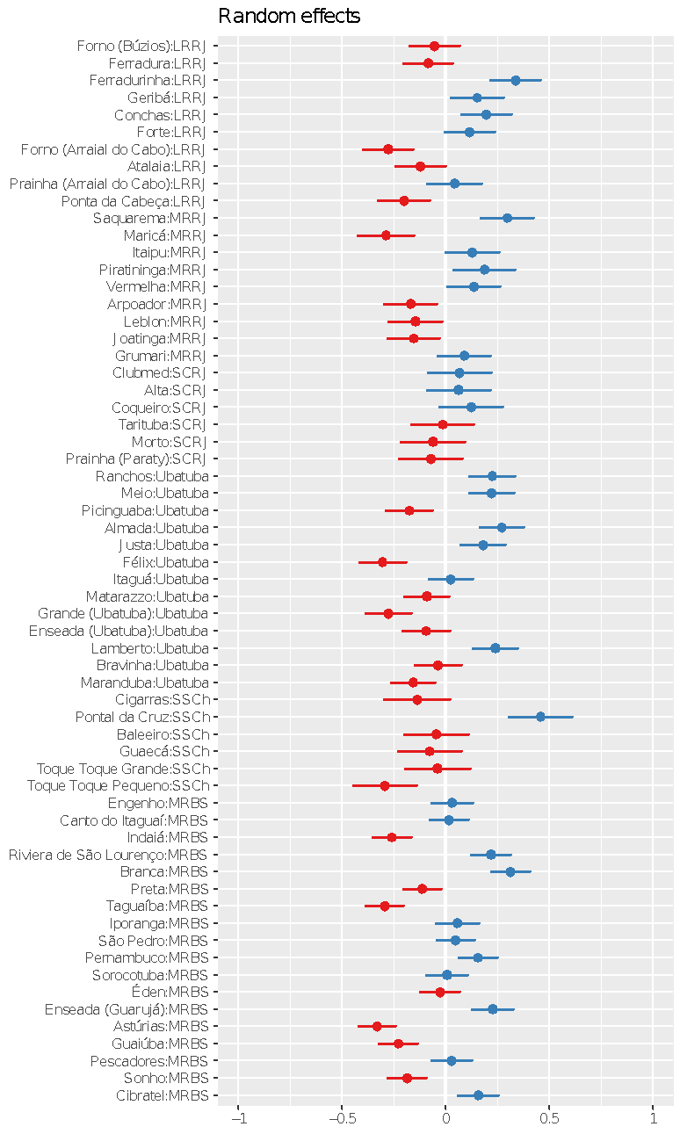

**Figure A8***.* Plots of random effects (location nested in subregion) for the null model for *Echinolittorina lineolata* size.

| (a) | (b) |
| --- | --- |

**Figure A9***.* Plots of random effects for the null model for *Echinolittorina lineolata* size and subregion (a), and for density and region (b).

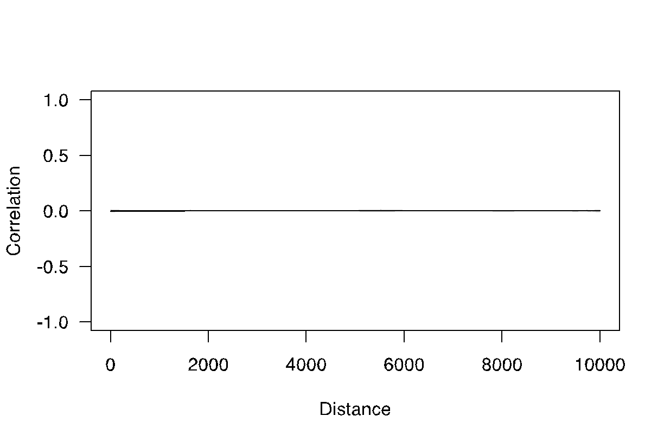

**Figure A10**. Spline correlogram (95% bootstrap confidence interval) using Pearson residuals from intercept-only model of *Echinolittorina lineolate* size variation along 62 rocky shores on southwestern Atlantic coast (Brazil).

| **Type** | **Variables** | **Stramonita** | | **Tetraclita** | | | **Lottia** | | **Echinolittorina** | | **Mytilaster** | |
| --- | --- | --- | --- | --- | --- | --- | --- | --- | --- | --- | --- | --- |
| **Size** | **Density** | **Size** | **Density** | **Presence** | **Size** | **Density** | **Size** | **Density** | **Size** | **Cover** |
| **Abiotic** | **SST** |  |  |  | **-** | **-** | **-** |  |  |  | **-** |  |
| **FWD** |  |  | **-** |  |  |  | **+** |  |  |  | **+** |
| **WF** |  | **+** |  |  |  |  | **-** |  |  |  | **+** |
| **Inclination** |  |  |  |  |  | **-** |  |  |  |  |  |
| **Rugosity** |  |  |  |  |  |  | **-** |  |  |  |  |
| **Northing** |  |  |  |  |  |  |  | **+** |  |  |  |
| **Production** | **Chlorophyll *a*** |  |  |  |  |  |  |  |  |  |  |  |
| **NDVI** |  |  |  |  |  |  |  |  |  |  |  |
| **Preys** | **Mytilaster (size)** |  |  |  |  |  |  |  |  |  |  |  |
| **Mytilaster (cover)** | **+** |  |  |  |  |  |  |  |  |  |  |
| **Perna (presence)** |  | **+** |  |  |  |  |  |  |  |  |  |
| **Predators** | **Stramonita (size)** |  |  |  |  |  |  |  |  |  |  |  |
| **Stramonita (abundance)** |  |  |  |  |  |  |  |  |  |  |  |